# Create an Azure Resource

<https://www.wintellect.com/azure-arm-template-tips/>

<https://www.red-gate.com/simple-talk/sysadmin/powershell/create-azure-vms-powershell-part-1/>

## VM

Windows Server 2012 R2

D drive data

Networking

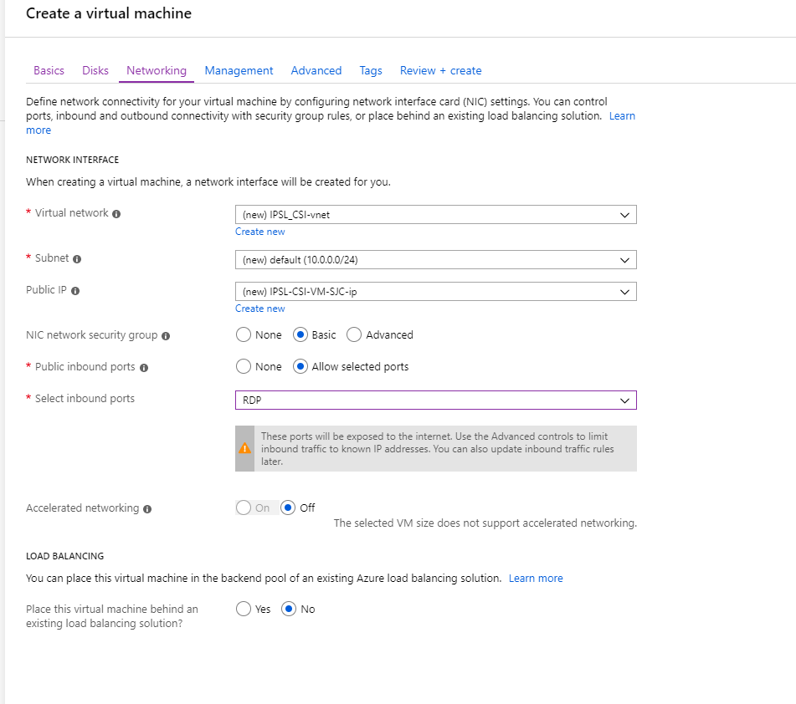

## SQL Server

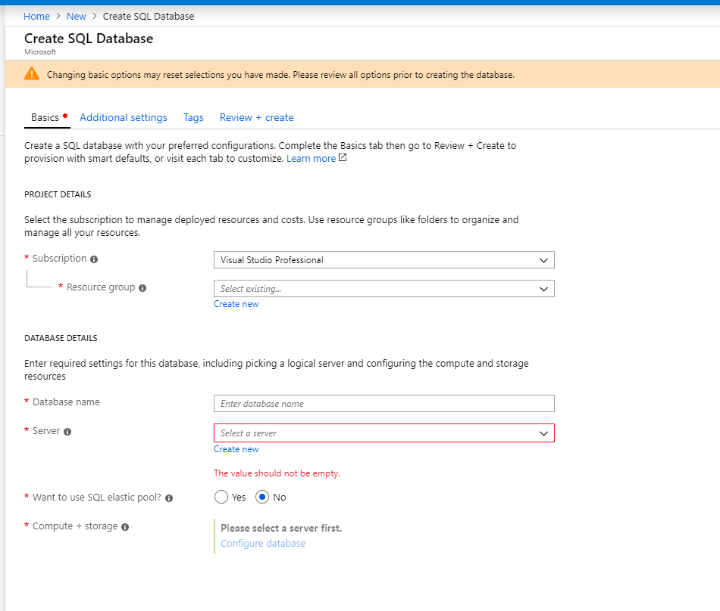

Resource group – a way of grouping the resources you create together e.g. IPSL SQL? IPSL Dev?

Existing for ref…

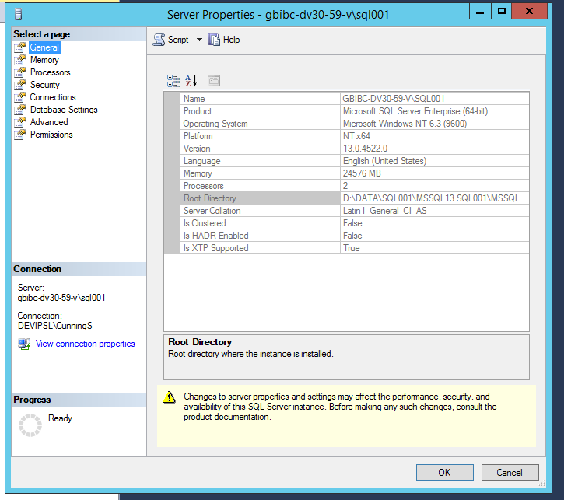

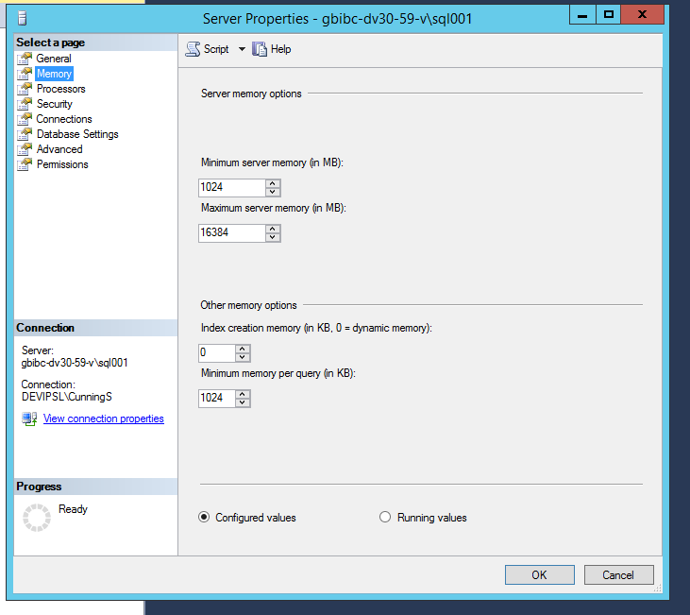

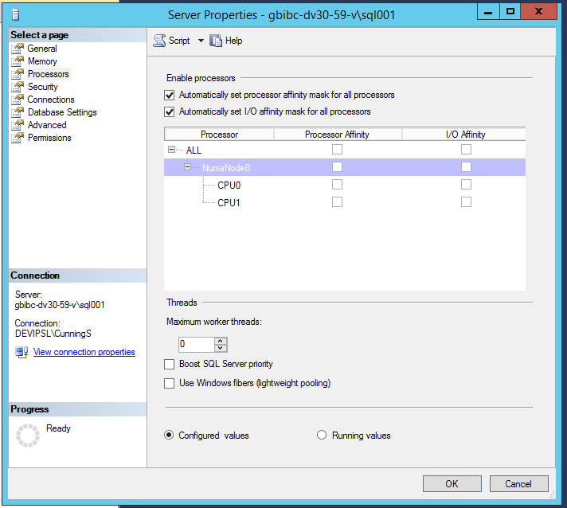

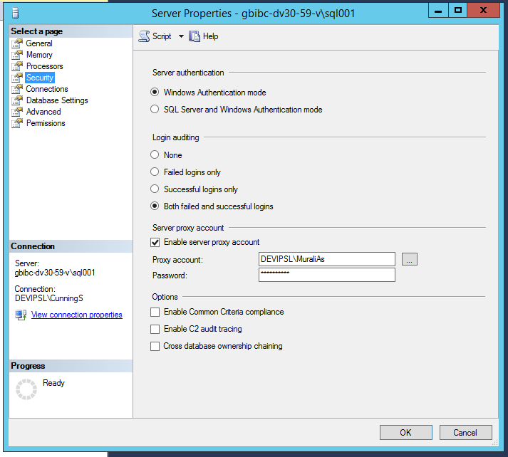

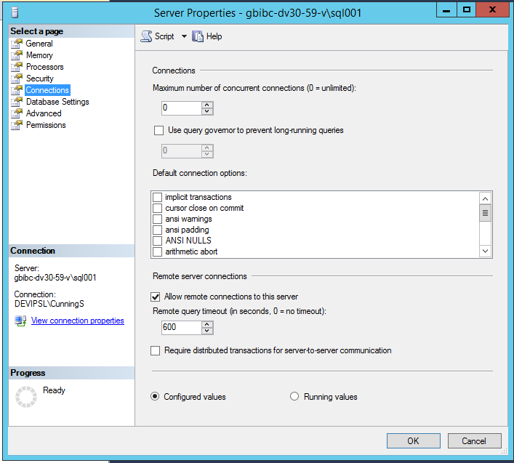

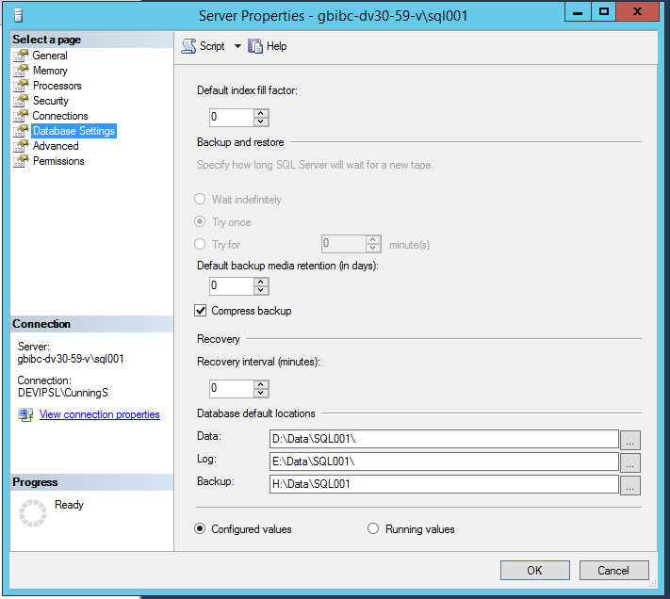

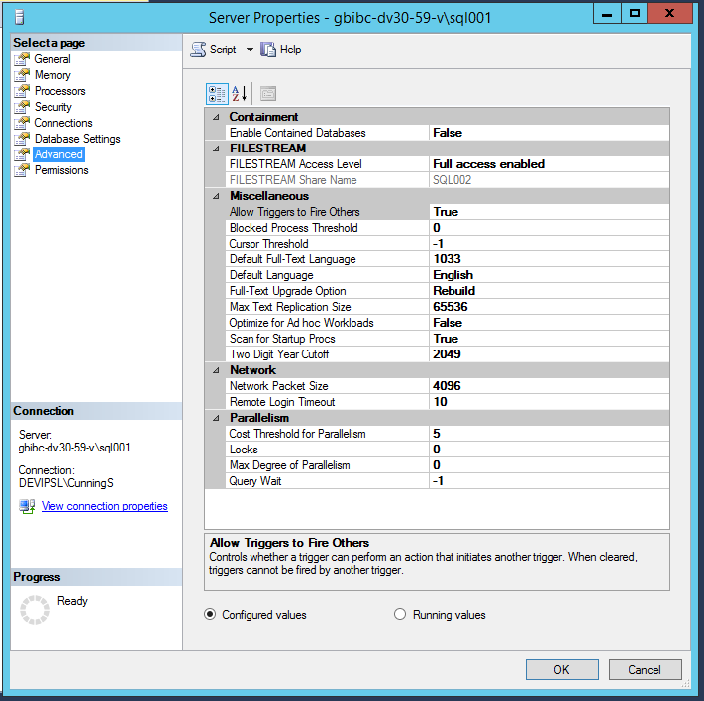

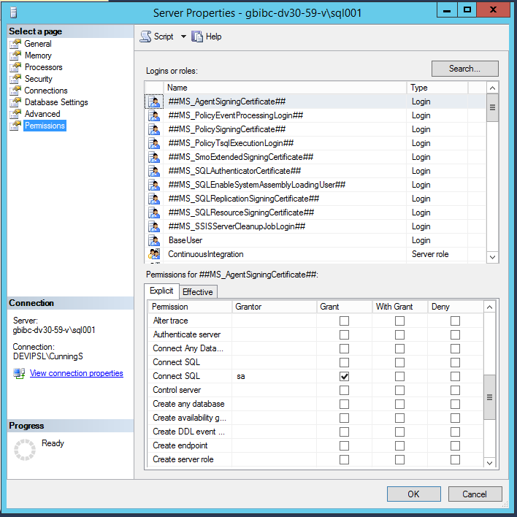

Visual Studio

Required?

VS Administrator Guide for how to silently install a product key

Refs

<https://www.petri.com/azure-sql-versus-sql-server-azure-vm>

Issues

Running a VM Azure template is problematic on your local machine as Power Shell default security insists all scripts are signed. The downloaded template is not, so will not execute.

One solution is as follows:

1. Run the Azure Active Directory Module for Windows PowerShell as an admin. To do this, click **Start**, click **All Programs**, click **Windows Azure Active Directory**, right-click **Windows Azure Active Directory Module for Windows PowerShell**, and then click **Run as administrator**.
2. Set the execution policy to Unrestricted. To do this, type the following cmdlet, and then press Enter:

Set-ExecutionPolicy Unrestricted

1. Run the Windows PowerShell cmdlets that you want.
2. Set the execution policy to Restricted. To do this, type the following cmdlet, and then press Enter:

Set-ExecutionPolicy Restricted

Sub - 7d69fcd7-fcfc-41e1-a5a9-cdcba1efce6f

ResourceGroupName – IPSL_CSI

DeploymentName – CSI_Test

????????????? Prompts for login – how to provide dynamically / automatically

<https://social.technet.microsoft.com/wiki/contents/articles/40062.azure-automating-login-for-powershell-scripts-using-service-principal.aspx>

????????????? How to authenticate – doesn’t look to be a problem initially

Resource group location – UKSouth or USEast

Rather than create the VM and then script, go through the steps of creating the VM until the final screen, then download the template rather than creating the VM.

The script can then be run from PowerShell.

The admin password is required.